Case Report

National Gallery DC

### Tracy’s iPhone [2012-07-15-National-Gallery]

# Table of Contents

Case Report

National Gallery DC

Tracy’s iPhone [2012-07-15-National-Gallery]

Table of Contents

Executive Summary

Equipment and Tools

Details of Tracy’s iPhone

Evidence to Establish Personas

Evidence relating to theft of valuable stamps

Evidence relating to defacement of museum art

Plot Timeline

Conclusion

Appendix A: Correspondence Evidence

Appendix B: WiFi and GPS Location Information

# Executive Summary

On January 21, 2016, Digitech Inc. was called in to assist the National Gallery, Washington D.C. (NGDC) with a case involving a conspiracy associated with the theft of valuable stamps and defacing of museums are at the NGDC.

* Joe is in the midst of a divorce. He discovered information on his wife’s phone that indicates a conspiracy involving NDC, her employer.
* Tracy is a suspect in the aforementioned conspiracy.
* As part of the investigation, Tracy’s iPhone was taken into custody.
* Digitech, Inc. was tasked with investigating evidence relevant to the aforementioned conspiracy.

As described fully in the report, Digitech, Inc. made the following findings.

* Alex is seeking to embarrass the United States and damage public relations by defacing foreign art belonging to Majavia that is on display at the National Gallery during the month of July.
* Tracy plans to steal stamps from the National Gallery during the flashmob public display put on by Alex and Carry. She is in contact with her brother, Pat who gets King involved in order to steal the stamps.
* Joe, Tracy's estranged husband, installed a keylogger on Tracy’s phone, discovered the conspiracy, and reported it to the police.

### Equipment and Tools

* Autopsy
* Google Maps
* SQL Lite Database Browser
* Kali Linux
* Text Editors

# Details of Tracy’s iPhone

|  |  |  |
| --- | --- | --- |
| **Name** | **Findings** | **Location in iPhone image file** |
| Model | iPhone 1,2 | tracy-phone/vol5/mobile/library/logs/applesupport/general.log |
| Host Name | Tracy-Sumtwelves-iPhone | tracy-phone/vol5/preference/systemconfigureation/preferences.plits |
| OS Version | iPhone OS 4.2.1 (8C148) | tracy-phone/vol5/mobile/library/logs/applesupport/general.log |
| Install Time | 6/6/2012 12:03:28 | tracy-phone/vol5/mobile/library/logs/applesupport/general.log |
| User Email | [tracysumtwelve@gmail.com](mailto:tracysumtwelve@gmail.com)  [tracy.sumtwelve@nationalgallerydc.org](mailto:tracy.sumtwelve@nationalgallerydc.org)  [coralbluetwo@hotmail.com](mailto:coralbluetwo@hotmail.com) | tracy-phone/vol5/mobile/library/mail |
| Phone Number | 1 (703) 340-9661 | lockdownd.log |
| Serial Number | 86004482Y7H | tracy-phone/vol5/mobile/library/logs/applesupport/general.log |
| ICCID | 89014103255195342366 | /logs/lockdownd.log.1 |
| IMEI | 012021003735398 | /root/Library/Lockdown/activation_records/wildcard_record.plist |
| MD5 Hash | 34c4888f095dc3241330462923f6fea5 |  |
| SHA256 Hash | 71aed05a86a753dec4ef4033ed7f52d6577ccb534ca0d1e83ffd27683e621607 |  |

# Evidence to Establish Personas

This section establishes aliases, phone numbers, emails addresses associated with each person, and relationships between each individual.

Tracy:

Phone Number: (703) 340-9961

Personal Email: [tracysumtwelve@gmail.com](mailto:tracysumtwelve@gmail.com) & [coralbluetwo@hotmail.com](mailto:coralbluetwo@hotmail.com) (alias used for job)

Work Email: tracy.sumtwelve@nationalgallerydc.org

Relationship: Accused

AKA: Coral

Pat:

Phone Number: (571) 308-3236

Email: patsumtwelve@gmail.com

Relationship: Brother to Tracy

AKA: Perry

Terry:

Phone Number: (703) 829-6071

Email: unknown

Relationship: Daughter of Tracy and Joe

Joe:

Phone Number: unknown

Email: joe.sum.twelve@gmail.com

Relationship: estranged husband of Tracy

Carry:

Phone Number: (202) 725-2124

Email: carrysum2012@yahoo.com

Relationship: in charge of flashmob at the museum

AKA: Cat

* Alex is a Krasnovian supporter who wishes to embarrass the United States. He lives outside the United States, presumably in a region called Krasnovia.
  + He knows Carry through extended family connections, and contacts her.
  + He plans to deface foreign works that are on exhibit at the National Gallery in DC. Defacing the artwork will embarrass the United States and possibly degrade the relationship between the United States and the foreign country.
* Carry is a somewhat criminally involved individual and Krasnovian supporter who shares family ties with Alex.
  + Carry is both technologically savvy and an occasional social media user. She is contacted by Alex in the beginning of the scenario and asked to orchestrate the defacing of the artwork because she is both aligned with Krasnovia and has "connections."
  + She is acquainted with Tracy.
* Tracy works as a supervisor at the National Gallery.
  + Carry contacts Tracy and starts sending her small pieces of data, telling Tracy that she wants to organize a flash mob at the gallery and needs a little help.
  + Carry offers to give Tracy money for this help. The items transferred are suspicious but not outright illegal. Tracy is having trouble with finances and this allows her to overlook the suspicious nature of the requests.
* Joe is currently going through a divorce with Tracy.
  + Joe is financially well-off and still bitter about the issues in their marriage.
  + Now that Joe and Tracy are going through a divorce, he has motivation to use the keylogger to spy on both Tracy and Terry, their daughter.
  + He previously installed a keylogger on the family's MacBook Air in an attempt to keep track of Terry's online behavior.
  + Joe used to have an account on the MacBook Air, but it was deleted. The home folder may have been preserved.
* Pat is a police officer in the D.C. Enforcers Bureau and Tracy's brother. He holds the status of detective and is very devoted to his sister and his niece Terry.
* King (aka Kart) is a co-conspirator recruited to participate in the robbery.

# Evidence relating to theft of valuable stamps

This sub-section provides details regarding the evidence found as it relates to the theft of valuable stamps.

Per the investigation the attempted theft of stamps was brought up by the accused and co-conspirators several times. The first mention of financial related issues can be seen in artifact seven where an email between Perry and Tracy were discussing ways to make money. This conversation leads to the suspects having a meet up that can be seen in artifact eight and 10. Later in artifact 13 the suspects clearly state the highly valuable stamp collection would be the target of their heist. Artifact 13 shows that Perry and Tracy add another accomplice to their heist, Mr. King (aka Kart). We can later see in artifact 18 insurance papers relating to the stamps were exchanged by both of Tracy’s email accounts. These documents were password protected, but to bypass this protection using autopsy the files were extracted directly from the iPhone image. The documents show the prices of the stamps the suspects wanted to steal and can be seen below. The final artifact that ties everything together can be found in artifact 21 where a needs.txt file was exchanged with all the items that would be used to commit the heist.

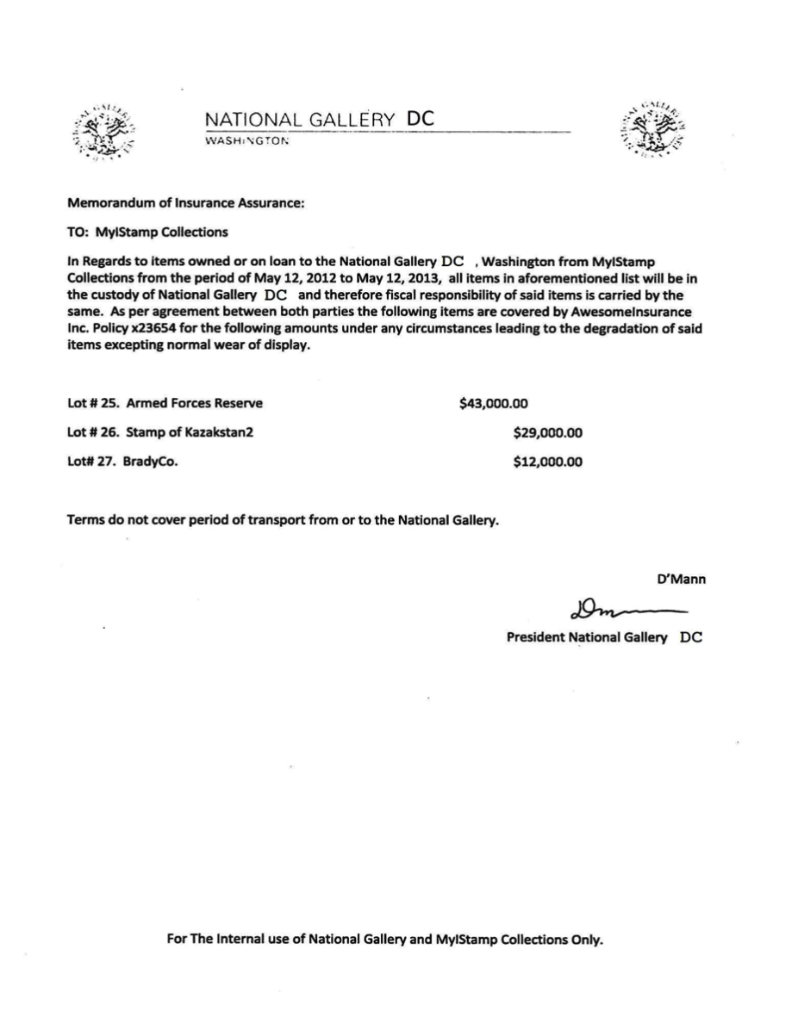

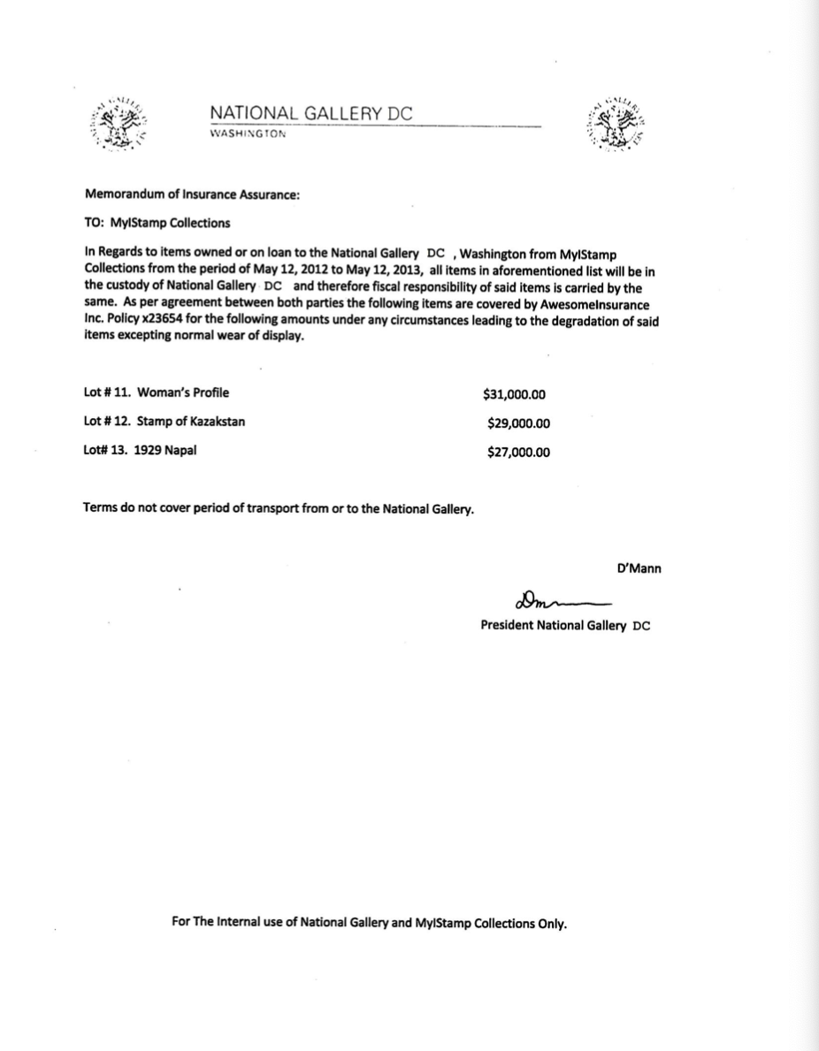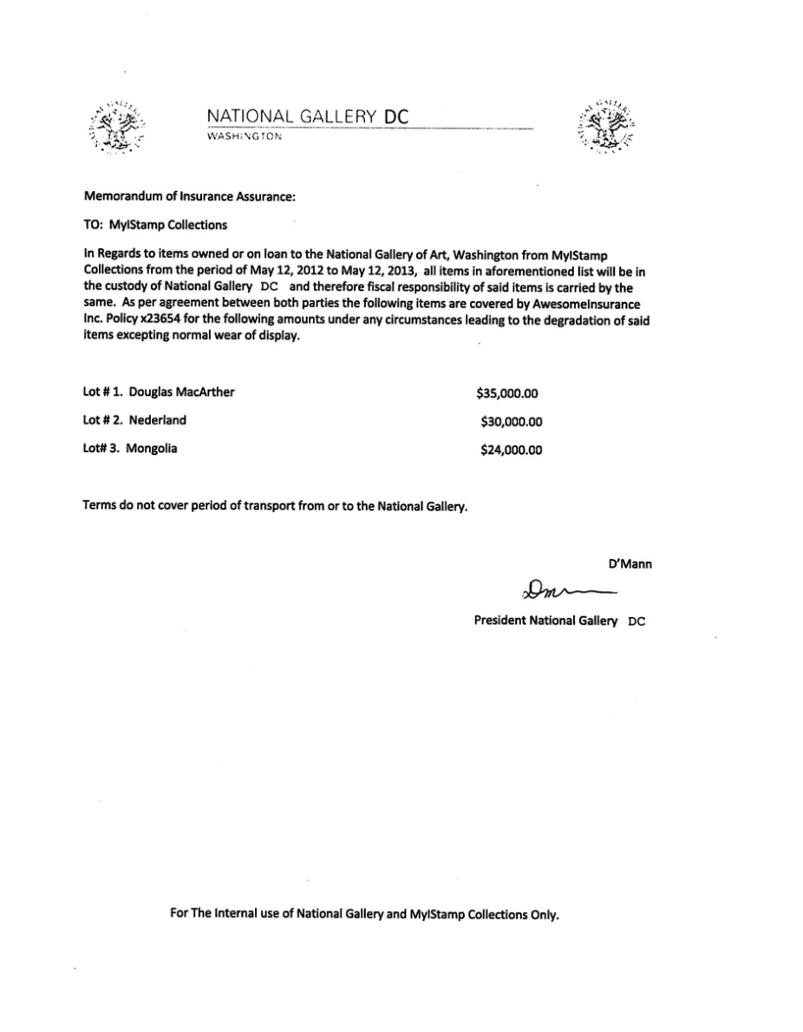

# Evidence relating to defacement of museum art

This sub-section provides details regarding the evidence found as it relates to the defacement of museum art.

The main plan was to embarrass the United States by putting together a plot to deface artwork belonging to Majavia which is on display at the National Gallery. This plot was to take place sometime in July. It would consist of a Flash Mob put together by Alex and Carry. Carry reaches out to Tracy asking her if she would like to meet up. She also mentions to Tracy that she is aware of the fact that she is having a difficult time. She states that she retrieved this information from Facebook. (Appendix A. Artifact 14)

Tracy and Carry had lunch. Carry emails Tracy asking for help sneaking in a tablet for the Flash Mob event that they had spoken about earlier. Carry mentioned to Tracy that she would be compensated. (Appendix A. Artifact 19)

Tracy agrees to help Carry with the plan. Carry request they meet at 9AM tomorrow. (Appendix A. Artifact 20)

# Plot Timeline

### 

|  |  |
| --- | --- |
| Master Timeline of NGDC | |
| Timestamp | Key Information |
| 6/19/2012 20:06:33 | Pat emails Tracy letting her know that he has accepted her proposal and asks her to email using her alias for further instructions. |
| 6/19/2012 20:26:47 | Pat (Perry) emails Tracy to ask her to communicate using her alias. |
| 6/19/2012 21:38:59 | Pat (Perry) emails Tracy (Coral) with instructions to install a Virtual Machine hidden in an audio file. |
| 6/19/2012 21:39:34 | Pat (Perry) replies to Tracy (Coral) confirming that he was getting her emails. |
| 6/21/2012 17:43:15 | Pat (Perry) replies to Tracy (Coral) on an email thread about Virtual Machine installation saying that she should listen to some other songs as well.  In the email thread Tracy (Coral) confirms that the instructions sent earlier in the audio file helped her. |
| 6/28/2012 19:31:33 | Pat (Perry) emails Tracy (Coral) asking her to henceforth communicate using the aliases and the Virtual Machine setup to keep them safer. He also indicates that they might have to get into riskier/illegal business since both of them were facing financial hardships.  He tells her that few of his workplace friends were good at these businesses and that he will inform her should something pop-up; in the meantime they should keep discussing some ideas for the same. |
| 6/29/2012 14:21:56 | This is an email thread between Pat (Perry) and Tracy (Coral) discussing ideas for making some money.  To Pat’s suggestion that they use the Virtual Machines and aliases to communicate and keep looking for ways to make money, Tracy replies that she will keep her eyes open for opportunities and insists that Pat try to get in on some business soon, since her kid didn’t want to change schools. She also indicates that she is paying attention to documents, especially insurance papers so that she could identify something of potential. Pat assures that he will make something happen although he is nervous because IA has been sniffing around. |
| 6/29/2012 14:31:36 | Pat (Perry) emails Tracy addressing her as ‘sister’ and enquires about Terry. Asks her to check in with Coral with whom he has been planning some things. He also suggests all of them going together for dinner as friends.  He asks Tracy to check in with Coral.  Possible misdirection attempted by referring to Coral as a third person in the narrative. |
| 6/29/2012 15:21:35 | Pat (Perry) replies to the email thread allaying Tracy’s (Coral) concern about IA sniffing around him. Tracy in her earlier email in the thread says that although nothing interesting has turned up yet she expects something soon. Pat in his email mentions that they can certainly get the job done if something like what they had earlier discussed pops up. |
| 7/2/2012 16:13:18 | Email Thread: Some good news  Tracy (Coral) emails Pat (Perry) mentioning that some interesting foreign exhibit is going to happen and that from assessing the paperwork she feels that it would be a big deal.  Pat (Perry) replies back feeling hopeful about this being the opportunity they were looking for. |
| 7/2/2012 20:00:31 | Email thread: Some good news  Following up on the earlier email about the exhibit, Tracy (Coral) mentions going through documents related to the exhibit from which she found that the exhibit is worth a lot of money but the shipping cost is very low comparatively.  Pat (Perry) emails back saying that such a thing may mean that the exhibit is something small which would be a very good thing for them. |
| 7/3/2012 13:29:37 | Email Thread: Regarding Terry  Tracy emails Joe asking whether he could help her with Terry’s tuition this year since it is becoming too expensive for her.  Joe replies back saying that he won’t be paying Terry’s tuition if she is not living with him. |
| 7/3/2012 14:53:04 | Email Thread: Some good news  Tracy (Coral) emails Pat (Perry) saying that the exhibit is rare and highly valuable stamp collection and that maybe this is their opportunity.  Pat (Perry) replies to Tracy (Coral) asking her to collect as much information as possible about the stamp exhibit and that in the meantime he would look into options for pulling off the heist. |
| 7/5/2012 15:51:31 | Carry reaches out to Tracy asking her if they could meet-up for lunch and suggests this Friday. She also mentions that through Facebook she realized that Tracy was having a hard time recently. |
| 7/6/2012 15:27:51 | Email Thread: Good News  Tracy emailed Pat saying that she spoke with Coral and that Coral got some great news about her job and suggested that Pat catch up with Coral.  Pat replied back saying that he knows a guy called King. |
| 7/6/2012 15:49:31 | Pat emails King with Tracy (Coral) in cc, saying that he has a lucrative proposition, a heist at the national gallery. He also threatens King to comply or else he would put King’s parole in jeopardy. |
| 7/6/2012 17:59:24 | Email Thread: Good News  Tracy suggests they (meaning King, Tracy and Pat) should hang out sometime.  Pat emails Tracy with account login information for:  coralblue@hotmail.com  Password: legalBee |
| 7/9/2012 14:44:11 | documents.zip is a compressed ZIP folder containing 3 insurance documents related to stamps.  docs.zip is an encrypted ZIP folder containing 3 insurance documents related to stamps. |
| 7/9/2012 18:18:47 | Email Thread: Long time no see... Tracy thanked Carry for the lunch.  Carry emails Tracy asking for help sneaking in a tablet for a flash mob event they had spoken earlier about. Carry suggests that Tracy would be compensated in some way for the help. |
| 7/10/2012 13:48:40 | Email Thread: Long time no see…  Tracy agrees to help Carry sneak in the tablet and asks when Carry would like to get in to take a look around the gallery.  Carry replies saying that this would be a big help and asks if she could come around 9 tomorrow. |
| 7/10/2012 15:24:57 | Email Thread: cant’ pass up  King agrees to help with the heist and sends in a document with equipment required for it. The attached document is saved as a ‘txt’ file.  Pat forwards that email to Tracy (Coral)  *needs.txt is a pdf file which was saved with a wrong extension. |
| 7/11/2012 17:06:19 | Email Thread: Long time no see  Tracy confirms the meet at 9 tomorrow.  Carry wants Tracy to pass her information regarding shift changes of security. She suggests that Tracy would be well compensated for the information.  Tracy confirms that she will give the security shift information Carry requested in exchange for money but asks Carry to be careful with it.  Carry replies asking Tracy not to worry and says “It will be gun”. |
| 7/11/2012 19:28:53 | Email Thread: Long time no see  Previous email from the thread from Carry asking for the security shift details from Tracy. |
| 7/11/2012 23:22:03 | Notification from Google+ informing Tracy that Carry had shared an album. |
| 7/12/2012 16:12:07 | Notification from Google+ informing Tracy that Carry had shared an album. |
| 7/12/2012 18:03:51 | Email Thread: Long time no see...  Tracy emailed Carry asking her what she meant by “It will be gun”.  Carry replies saying that it was a typographical error and she meant “It will be fun”. |
| 6/12/2012 21:25:04 | Pat asks Tracy about her plans for the weekend |
| 6/13/2012 17:30:28 | I'm going out with dad after school for pizza! Thought I'd let you know if you planned to cook. T |
| 6/13/2012 18:30:38 | Tracy replies to Pats message saying that she has no big plans and enquires about his plans. |
| 6/13/2012 18:33:46 | Ok, sounds good. |
| 7/3/2012 14:04:32 | Terry replies back saying that she doesn’t want to switch schools and would rather stay with her dad and continue at Prufrock |
| 7/5/2012 18:18:23 | Carry sets up the time and location as 1pm at Bubba’s grill for meeting with Tracy |
| 7/5/2012 18:20:26 | Tracy confirms the meeting time and location |
| 7/6/2012 15:02:19 | Tracy asks Pat to give her a call |
| 7/6/2012 15:08:37 | Pat says he is busy and suggests calling later |
| 7/6/2012 15:11:54 | Tracy says its important and insists that pat call her soon |
| 7/6/2012 15:13:31 | Pat says he will call in 5 min |
| 7/6/2012 15:18:50 | Pat calls Tracy and they speak for 4 min 4 secs. |
| 7/6/2012 16:27:16 | Carry messages saying she has a table inside |
| 7/6/2012 16:27:50 | Tracy replies back saying that she will be there. |
| 7/10/2012 15:26:19 | Pat messages Tracy telling her about the email and informing that the attachment needs to be changed to pdf. He asks Tracy to tell this information to Coral. |
| 7/10/2012 15:58:04 | Tracy acknowledges the email and message. |
| 7/10/2012 16:37:09 | Tracy tried to share the following location with Pat over MMS message but it failed. Location: 2600-2700 24th Rd S, Arlington, VA 22206 |
| 7/10/2012 17:18:38 | Tracy messages Terry for Lunch |
| 7/10/2012 18:19:24 | Tracy messages Terry that she is back at work. |
| 7/10/2012 18:58:24 | Terry messages Tracy saying she is busy and suggests meeting up over the weekend if her dad isn’t busy. |
| 7/11/2012 12:41:45 | Carry messages Tracy informing that she is almost there (National Gallery) |
| 7/11/2012 12:49:08 | Tracy replies to Carry asking her to meet out front. She says that she will take the tablet in. |
| 7/13/2012 1:02:10 | I really want to go to Dad's this weekend. He said he'll take me shopping for school |
|  | This is an attachment from King (Pat’s thief contact on parole) to CoralBlue (Tracy)  needs. Txt   * A rope and javelin (using alternative means to break in) * Tactical turtlenecks ( what i will be wearing) * Spray paint (for the cameras) * Vibram five finger shoes (in order to walk silently) * Pack of smokes (detecting lasers) * Smoke grenades (use as a means of escape if caught) |

### 

# Conclusion

Evidence found on Tracy’s iPhone indicated the following:

* Tracy is financially strained as a result of her ongoing divorce from Joe. She is also worried that she will lose custody of their daughter, Terry.
* Joe installed a keylogger on Tracy’s phone to track her behavior and as a result became aware of the plot involving the National Gallery. Joe informed the police of his discovery.
* The investigation of Tracy’s phone revealed many details of a conspiracy to steal art from the National Museum, including several of Tracy’s co-conspirators.
* Aliases, where known, are listed in the Evidence to Establish Personas sections of this document.

# Appendix A: Correspondence Evidence

This subsection will provide an amalgamation of the email and SMS corresponce evidence.

### 

|  |  |  |  |  |
| --- | --- | --- | --- | --- |
| Master Timeline of NGDC | | | | |
| Artifact # | Timestamp | Header Information | Key Information | Evidence Location |
| 1. | 6/19/2012 20:06:33 | F: patsumtwelve@gmail.com  T: tracysumtwelve@gmail.com  Subject: Paris Speak and answer | Pat emails Tracy letting her know that he has accepted her proposal and asks her to email using her alias for further instructions. | Mailbox Data Structure |
| 2. | 6/19/2012 20:26:47 | F: perrypatsum@yahoo.com  T: tracysumtwelve@gmail.com  Subject: Look me up sometime | Pat (Perry) emails Tracy to ask her to communicate using her alias. | Mailbox Data Structure |
| 3. | 6/19/2012 21:38:59 | F: perrypatsum@yahoo.com  T: coralbluetwo@hotmail.com  Subject: Crazydave by the VMs Attachment: Crazydave1.mp3 | Pat (Perry) emails Tracy (Coral) with instructions to install a Virtual Machine hidden in an audio file. | Mailbox Data Structure |
| 4. | 6/19/2012 21:39:34 | F: perrypatsum@yahoo.com  T: coralbluetwo@hotmail.com  Subject: Re: ??? | Pat (Perry) replies to Tracy (Coral) confirming that he was getting her emails. | Mailbox Data Structure |
| 5. | 6/21/2012 17:43:15 | F: perrypatsum@yahoo.com  T: coralbluetwo@hotmail.com  Subject: Re: Crazydave by the VMs | Pat (Perry) replies to Tracy (Coral) on a email thread about Virtual Machine installation saying that she should listen to some other songs as well.  In the email thread Tracy (Coral) confirms that the instructions sent earlier in the audio file helped her. | Mailbox Data Structure |
| 6. | 6/28/2012 19:31:33 | 6/28/2012 19:31:33  F: perrypatsum@yahoo.com  T: coralbluetwo@hotmail.com  Subject: Whats going on | Pat (Perry) emails Tracy (Coral) asking her to henceforth communicate using the aliases and the Virtual Machine setup to keep them safer. He also indicates that they might have to get into riskier/illegal business since both of them were facing financial hardships.  He tells her that few of his workplace friends were good at these businesses and that he will inform her should something pop-up; in the meantime they should keep discussing some ideas for the same. | Mailbox Data Structure |
| 7. | 6/29/2012 14:21:56 | F: perrypatsum@yahoo.com  T: coralbluetwo@hotmail.com  Subject: Re: Whats going on | This is an email thread between Pat (Perry) and Tracy (Coral) discussing ideas for making some money.  To Pat’s suggestion that they use the Virtual Machines and aliases to communicate and keep looking for ways to make money, Tracy replies that she will keep her eyes open for opportunities and insists that Pat try to get in on some business soon, since her kid didn’t want to change schools. She also indicates that she is paying attention to documents especially insurance papers so that she could identify something of potential. Pat assures that he will make something happen although he is nervous because IA has been sniffing around. | Mailbox Data Structure |
| 8. | 6/29/2012 14:31:36 | F: perrypatsum@yahoo.com  T: tracysumtwelve@gmail.com  Subject: hey sis | Pat (Perry) emails Tracy addressing her as ‘sister’ and enquires about Terry. Asks her to check in with Coral with whom he has been planning some things. He also suggests all of them going together for dinner as friends.  He asks Tracy to check in with Coral.  Possible misdirection attempted by referring to Coral as a third person in the narrative. | Mailbox Data Structure |
| 9. | 6/29/2012 15:21:35 | F: perrypatsum@yahoo.com  T: coralbluetwo@hotmail.com  Subject: Re: Whats going on | Pat (Perry) replies to the email thread allaying Tracy’s (Coral) concern about IA sniffing around him. Tracy in her earlier email in the thread says that although nothing interesting has turned up yet she expects something soon. Pat in his email mentions that they can certainly get the job done if something like what they had earlier discussed pops up. | Mailbox Data Structure |
| 10. | 7/2/2012 16:13:18 | F: perrypatsum@yahoo.com  T: coralbluetwo@hotmail.com  Subject: Re: Some good news | Email Thread: Some good news  Tracy (Coral) emails Pat (Perry) mentioning that some interesting foreign exhibit is going to happen and that from assessing the paperwork she feels that it would be a big deal.  Pat (Perry) replies back feeling hopeful about this being the opportunity they were looking for. | Mailbox Data Structure |
| 11. | 7/2/2012 20:00:31 | F: perrypatsum@yahoo.com  T: coralbluetwo@hotmail.com  Subject: Re: Some good news | Email thread: Some good news  Following up on the earlier email about the exhibit, Tracy (Coral) mentions going through documents related to the exhibit from which she found that the exhibit is worth a lot of money but the shipping cost is very low comparatively.  Pat (Perry) emails back saying that such a thing may mean that the exhibit is something small which would be a very good thing for them. | Mailbox Data Structure |
| 12. | 7/3/2012 13:29:37 | F: joe.sum.twelve@gmail.com  T: tracysumtwelve@gmail.com  Subject: Re: Regarding Terry | Email Thread: Regarding Terry  Tracy emails Joe asking whether he could help her with Terry’s tuition this year since it is becoming too expensive for her.  Joe replies back saying that he won’t be paying Terry’s tuition if she is not living with him. | Mailbox Data Structure |
| 13. | 7/3/2012 14:53:04 | F: perrypatsum@yahoo.com  T :coralbluetwo@hotmail.com  Subject: Re: Some good news | Email Thread: Some good news  Tracy (Coral) emails Pat (Perry) saying that the exhibit is rare and highly valuable stamp collection and that may be this is their opportunity.  Pat (Perry) replies to Tracy (Coral) asking her to collect as much information as possible about the stamp exhibit and that in the meantime he would look into options for pulling off the heist. | Mailbox Data Structure |
| 14. | 7/5/2012 15:51:31 | F: carrysum2012@yahoo.com  T: tracysumtwelve@gmail.com  Subject: Long time no see... | Carry reaches out to Tracy asking her if they could meet-up for lunch and suggests this Friday. She also mentions that through Facebook she realized that Tracy was having a hard time recently. | Mailbox Data Structure |
| 15. | 7/6/2012 15:27:51 | F: patsumtwelve@gmail.com  T: tracysumtwelve@gmail.com  Subject: Re: Good News | Email Thread: Good News  Tracy emailed Pat saying that she spoke with Coral and that Coral got some great news about her job and suggested that Pat catch up with Coral.  Pat replied back saying that he knows a guy called King. | Mailbox Data Structure |
| 16. | 7/6/2012 15:49:31 | F: patsumtwelve@gmail.com  T: throne1966@hotmail.com  Cc:coralbluetwo@hotmail.com  Subject: can't pass up | Pat emails King with Tracy (Coral) in cc, saying that he has a lucrative proposition, a heist at national gallery. He also threatens King to comply or else he would put King’s parole in jeopardy. | Mailbox Data Structure |
| 17. | 7/6/2012 17:59:24 | F: patsumtwelve@gmail.com  T: tracysumtwelve@gmail.com  Subject: Re: Good News | Email Thread: Good News  Tracy suggests they (meaning King, Tracy and Pat) should hang out sometime.  Pat emails Tracy with account login information for:  coralblue@hotmail.com  Password: legalBee | Mailbox Data Structure |
| 18. | 7/9/2012 14:44:11 | F: tracysumtwelve@gmail.com  T: coralbluetwo@hotmail.com  Subject: things | documents.zip is a compressed ZIP folder containing 3 insurance documents related to stamps.  docs.zip is an encrypted ZIP folder containing 3 insurance documents related to stamps. | /mobile/Librar y/Mail/POP- coralbluetwo @hotmail.com @pop3.live.co m/INBOX.mbo x/Messages/8 A3BD06F- CDB1-4453- 9C69- 77E06823F2A E.emlx |
| 19. | 7/9/2012 18:18:47 | F: carrysum2012@yahoo.com  T: tracysumtwelve@gmail.com  Subject: Re: Long time no see.. | Email Thread: Long time no see... Tracy thanked Carry for the lunch.  Carry emails Tracy asking for help sneaking in a tablet for a flash mob event they had spoken earlier about. Carry suggests that Tracy would be compensated in some way for the help. | Mailbox Data Structure |
| 20. | 7/10/2012 13:48:40 | F: carrysum2012@yahoo.com  T: tracysumtwelve@gmail.com  Subject: Re: Long time no see... | Email Thread: Long time no see…  Tracy agrees to help Carry sneak in the tablet and asks when Carry would like to get in to take a look around the gallery.  Carry replies saying that this would be a big help and asks if she could come around 9 tomorrow. | Mailbox Data Structure |
| 21 | 7/10/2012 15:24:57 | F: patsumtwelve@gmail.com  T: coralbluetwo@hotmail.com  Subject: Fwd: can't pass up  Attachment: needs.txt | Email Thread: can't’ pass up  King agrees to help with the heist and sends in a document with equipment required for it. The attached document is saved as a ‘txt’ file.  Pat forwards that email to Tracy (Coral)  *needs.txt is a pdf file which was saved with a wrong extension.  This is an attachment from King (Pat’s thief contact on parole) to CoralBlue (Tracy)  needs. Txt   * A rope and javelin (using alternative means to break in) * Tactical turtlenecks ( what i will be wearing) * Spray paint (for the cameras) * Vibram five finger shoes (in order to walk silently) * Pack of smokes (detecting lasers) * Smoke grenades (use as a means of escape if caught) | /mobile/Librar y/Mail/POP- coralbluetwo @hotmail.com @pop3.live.co m/INBOX.mbo x/Messages/9 F0508B8- 04FB-490E- A7F0- 3E23B0E7C5 9B.emlx |
| 22. | 7/11/2012 17:06:19 | F: carrysum2012@yahoo.com  T: tracysumtwelve@gmail.com  Subject: Re: Long time no see... | Email Thread: Long time no see  Tracy confirms the meet at 9 tomorrow.  Carry wants Tracy to pass her information regarding shift changes of security. She suggests that Tracy would be well compensated for the information.  Tracy confirms that she will give the security shift information Carry requested in exchange for money but asks Carry to be careful with it.  Carry replies asking Tracy not to worry and says “It will be gun”. | Mailbox Data Structure |
| 23. | 7/11/2012 19:28:53 | F: "Google+" <noreply- 5dd47ca1@plus.google.com>  T: tracysumtwelve@gmail.com  Subject: Carry Carsumtwotwelve added you on Google+ | Email Thread: Long time no see  Previous email from the thread from Carry asking for the security shift details from Tracy. | Mailbox Data Structure |
| 24. | 7/11/2012 23:22:03 | F: "Carry Carsumtwotwelve (Google+)" <replyto- 748d3d22@plus.google.com>  T: tracysumtwelve@gmail.com    Subject: Carry Carsumtwotwelve is sharing with you on Google+ | Notification from Google+ informing Tracy that Carry had shared an album. | Mailbox Data Structure |
| 25. | 7/12/2012 16:12:07 | F: "Carry Carsumtwotwelve (Google+)" <replyto- 748d3d22@plus.google.com>  T: tracysumtwelve@gmail.com  Subject: Carry Carsumtwotwelve is sharing with you on Google+ | Notification from Google+ informing Tracy that Carry had shared an album. | Mailbox Data Structure |
| 26. | 7/12/2012 18:03:51 | F: carrysum2012@yahoo.com  T: tracysumtwelve@gmail.com  Subject: Re: Long time no see... | Email Thread: Long time no see...  Tracy emailed Carry asking her what she meant by “It will be gun”.  Carry replies saying that it was a typographical error and she meant “It will be fun”. | Mailbox Data Structure |
| 27. | 6/12/2012 21:25:04 | F: Pat  T: Tracy | Pat asks Tracy about her plans for the weekend | SMS |
| 28. | 6/13/2012 17:30:28 | F: Terry  T: Tracy | I'm going out with dad after school for pizza! Thought I'd let you know if you planned to cook. T | SMS |
| 29. | 6/13/2012 18:30:38 | F: Tracy  T: Pat | Tracy replies to Pats message saying that she has no big plans and enquires about his plans. | SMS |
| 30. | 6/13/2012 18:33:46 | F: Tracy  T: Terry | Ok, sounds good. | SMS |
| 31. | 7/3/2012 14:04:32 | F: Terry T: Tracy | Terry replies back saying that she doesn’t want to switch schools and would rather stay with her dad and continue at Prufrock | SMS |
| 32. | 7/5/2012 18:18:23 | F: Carry T: Tracy | Carry sets up the time and location as 1pm at Bubba’s grill for meeting with Tracy | SMS |
| 33. | 7/5/2012 18:20:26 | F: Tracy T: Carry | Tracy confirms the meeting time and location | SMS |
| 34. | 7/6/2012 15:02:19 | F: Tracy T: Pat | Tracy asks Pat to give her a call | SMS |
| 35. | 7/6/2012 15:08:37 | F: Pat T: Tracy | Pat says he is busy and suggests calling later | SMS |
| 36. | 7/6/2012 15:11:54 | F: Tracy T: Pat | Tracy says its important and insists that pat call her soon | SMS |
| 37. | 7/6/2012 15:13:31 | F: Pat T: Tracy | Pat says he will call in 5 min | SMS |
| 38. | 7/6/2012 15:18:50 | F: Pat T: Tracy | Pat calls Tracy and they speak for 4 min 4 secs. | SMS |
| 39. | 7/6/2012 16:27:16 | F: Carry  T: Tracy | Carry messages saying she has a table inside | SMS |
| 40. | 7/6/2012 16:27:50 | F: Tracy  T: Carry | Tracy replies back saying that she will be there. | SMS |
| 41. | 7/10/2012 15:26:19 | F: Pat  T: Tracy | Pat messages Tracy telling her about the email and informing that the attachment needs to be changed to pdf. He asks Tracy to tell this information to Coral. | SMS |
| 42. | 7/10/2012 15:58:04 | F: Tracy  T: Pat | Tracy acknowledges the email and message. | SMS |
| 43. | 7/10/2012 16:37:09 | F: Tracy T: Pat *Failed | Tracy tried to share the following location with Pat over MMS message but it failed. Location: 2600-2700 24th Rd S, Arlington, VA 22206 | SMS |
| 44. | 7/10/2012 17:18:38 | F: Tracy T: Terry | Tracy messages Terry for Lunch | SMS |
| 45. | 7/10/2012 18:19:24 | F: Tracy T: Terry | Tracy messages Terry that she is back at work. | SMS |
| 46. | 7/10/2012 18:58:24 | F: Terry T: Tracy | Terry messages Tracy saying she is busy and suggests meeting up over the weekend if her dad isn’t busy. | SMS |
| 47. | 7/11/2012 12:41:45 | F: Carry T: Tracy | Carry messages Tracy informing that she is almost there (National Gallery) | SMS |
| 48. | 7/11/2012 12:49:08 | F: Tracy T: Carry | Tracy replies to Carry asking her to meet out front. She says that she will take the tablet in. | SMS |
| 49. | 7/13/2012 1:02:10 | F: Terry T: Tracy | I really want to go to Dad's this weekend. He said he'll take me shopping for school | SMS |

# Appendix B: WiFi and GPS Location Information

### 

|  |  |  |  |  |
| --- | --- | --- | --- | --- |
| Location Information | | | | |
| Artifact # | Timestamp | Header Information | Body | Map Screenshot |
| 1. | 3.61306882473715E8 - 3.61306882473715E8 | 38.88055896 -77.11553561 - 38.87969988 -7711591041 | 900 N Glebe Rd, Arlington, VA 22203 - 801 N Wakefield St, Arlington, VA 22203 |  |
| 2. | 3.613070437433548E8 - 3.62938764797761E8 | 38.88143724 -77.11478394 - 38.88098716 -77.11352664 | 851 N Glebe Rd, Arlington, VA 22203 - Virginia Square, Arlington, VA 22203 |  |
| 3. | 3.63015762683134E8 - 3.63015762683134E8 | 38.88062763 -77.11558109 - 38.88156855 -77.11573243 | 900 N Glebe Rd, Arlington, VA 22203 - 982-900 N Glebe Rd, Arlington, VA 22203 |  |
| 4. | 3.63198767554628E8 - 3.63015762683134E8 | 38.88054466 -77.11439651 - 38.88145855 -77.11573243 | 801 N Glebe Rd, Arlington, VA 22203 - 982-900 N Glebe Rd, Arlington, VA 22203 |  |
| 5. | 3.63198767554628E8 - 3.63198767554628E8 | 38.8805446 -77.11439651 - 38.88094735 -77.11348152 | 801 N Glebe Rd, Arlington, VA 22203 - Virginia Square, Arlington, VA 22203 |  |
| 6. | 3.63630672185595E8 - 3.63630672185595E8 | 38.84833276 -77.08220279 - 38.84957695 -77.08302992 | 2693 24th Rd S, Arlington, VA 22206 - 2915 23rd St S, Arlington, VA 22206 |  |
| 7. | 3.63630672185595E8 - 3.63630672185595E8 | 38.84837096 -77.08217364 - 38.84806352 -77.08156085 | 2693 24th Rd S, Arlington, VA 22206 - 2704 24th Rd S, Arlington, VA 22206 |  |
| 8. | 3.63630672745583E8 - 3.63631501716626E8 | 38.84830218 -77.08210736 - 38.84957695 -77.08302992 | 2691 24th Rd S, Arlington, VA 22206 - 2915 23rd St S, Arlington, VA 22206 |  |
| 9. | 3.63630672185595E8 - 3.63630672185595E8 | 38.84837096 -77.08217364 - 38.84806352 -77.08156085 | 2693 24th Rd S, Arlington, VA 22206 - 2704 24th Rd S, Arlington, VA 22206 |  |
| 10. | 3.63630672745583E8 - 3.63198766054534E8 | 38.84830218 -77.08210736 - 38.94208306 -77.0148946 | 2691 24th Rd S, Arlington, VA 22206 - 226 Upshur St NW, Washington, DC 20011 |  |
| 11. | 3.63630670503151E8 - 3.63631499997881E8 | 38.85141718 -77.07823592 - 38.90048003 -76.99235898 | 1702 Army Navy Dr, Arlington, VA 22202 - 1002 H St NE, Washington, DC 20002 |  |

### Data was taken as start and stop locations along the way. All data was found in consolidated.db, 2021-07-12, /img/tracy-phone-2021-07-15-final.E01/vol_vol5/root/Library/Caches/location/consolidated.db in Tracey’s iPhone.